Handout for Asking ‘What?’ and ‘How Much?’: Quantitative Approaches

Opening activity
You are Medical Education and/or Health Science faculty who wants to publish an education study. For each scenario:
1. Identify the type of study (descriptive, correlational, causal-comparative, quasi-experimental).
2. Design a research question that would be considered “good”.
Scenario 1
Students who elect an interprofessional simulation elective are compared with those who do not on teamwork scores during clinical placements.
Type of study: ☐Descriptive ☐Correlational ☐ Causal-comparative ☐ quasi-experimental
Good research question: ______________________________________________________

Scenario 2
Faculty examine whether students’ anatomy course grades are associated with performance on first clinical rotation evaluations.
Type of study: ☐Descriptive ☐Correlational ☐ Causal-comparative ☐ quasi-experimental
Good research question: ______________________________________________________

Scenario 3
A PA program surveys second-year students about their confidence performing first aid techniques and reports mean confidence scores.
Type of study: ☐Descriptive ☐Correlational ☐ Causal-comparative ☐ quasi-experimental
Good research question: ______________________________________________________

Scenario 4
One cohort of nursing students receives a structured reflection curriculum during clinical rotations; the prior cohort did not. Clinical reasoning scores are compared at the end of the year.
Type of study: ☐Descriptive ☐Correlational ☐ Causal-comparative ☐ quasi-experimental
Good research question: ______________________________________________________

What type of studies are the following?
1. Relationship Between Emotional Intelligence and Clinical Performance in Medical Students – uses EI scale + clinical evaluation scores.
Type of study ☐Descriptive ☐Correlational ☐ Causal-comparative ☐ quasi-experimental
2. Empathy Levels in Students from Rural vs Urban Backgrounds
Type of study ☐Descriptive ☐Correlational ☐ Causal-comparative ☐ quasi-experimental
3. Sleep Patterns of Nursing Students During Clinical Rotations – used Self-reported sleep diaries across one semester
Type of study ☐Descriptive ☐Correlational ☐ Causal-comparative ☐ quasi-experimental
4. Introduction of Reflective Journaling to Improve Clinical Reasoning – uses Pre/post rubric scoring.
Type of study ☐Descriptive ☐Correlational ☐ Causal-comparative ☐ quasi-experimental

On your own
- What is the research question that you would like to answer?

  - Why does this matter in your program?

- What variables are important? How can they be measured?

- Modify it to be a
  - As a descriptive study

  - As a correlational study

  - As a causal-comparative study

  - As a quasi-experimental study

Review your research question in descriptive, correlational, causal-comparative, quasi-experimental form.
- Which version is strongest?
- Which is most feasible?
- Which requires the most resources?
- Which risks over-claiming causality?
- Modify your question to make it what you want to do. Consider a conceptual framework
that would work with your study.

- Be prepared to share.

Group activity
- Share your research question
- Help each other to make it better by using I-SMART and any other questions you may have

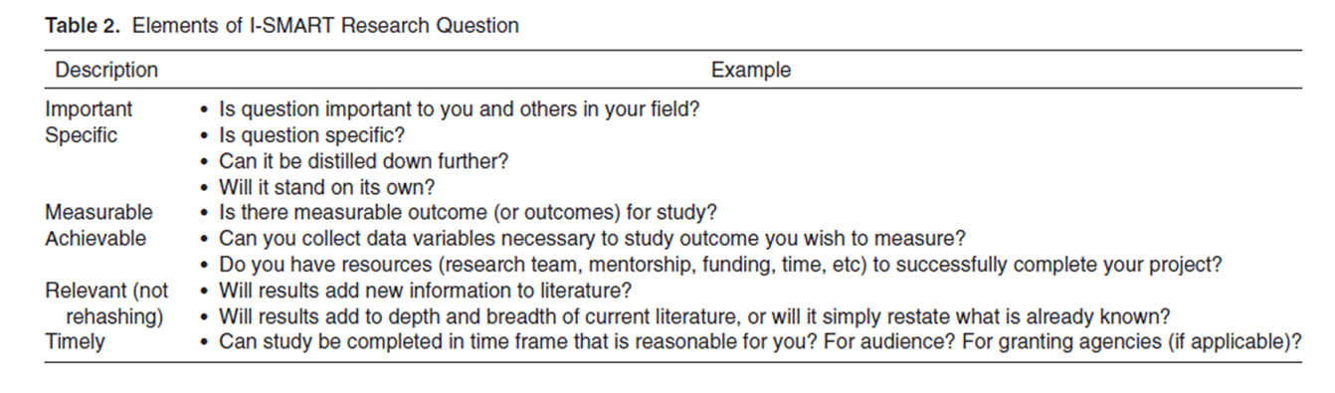

References:
Abramson, E. L., Paul, C. R., Petershack, J., Serwint, J., Fischel, J. E., Rocha, M., Treitz, M., McPhillips, H., Lockspeiser, T., Hicks, P., Tewksbury, L., Vasquez, M., Tancredi, D. J., & Li, S. T. (2018). Conducting Quantitative Medical Education Research: From Design to Dissemination. Academic Pediatrics, 18(2), 129–139. https://doi.org/10.1016/j.acap.2017.10.008
Ma T, Lee Y. (2026) Overview of Quantitative Research. Family Medicine. 58(2):81-87. https://doi.org/10.22454/FamMed.2026.406133
Additional resources:
Centre for Evidence Based Medicine - https://www.cebm.net/2014/04/study-designs
Part of a larger Medical Education series from Baylor College of Medicine: https://youtu.be/DQCANdAPFbo
Series: https://www.bcm.edu/departments/huffington-department-of-education-innovation-technology/educational-research-mini-series/topic-quantitative-research

